Jonathan Patten’s Portal Page Site Plan
Purpose: A site for marketing food (sisig)

Audience: people who eat sisig, people who doint know sisig

Branding: Sizzling sisig for your whole family (family deals)

Logo:
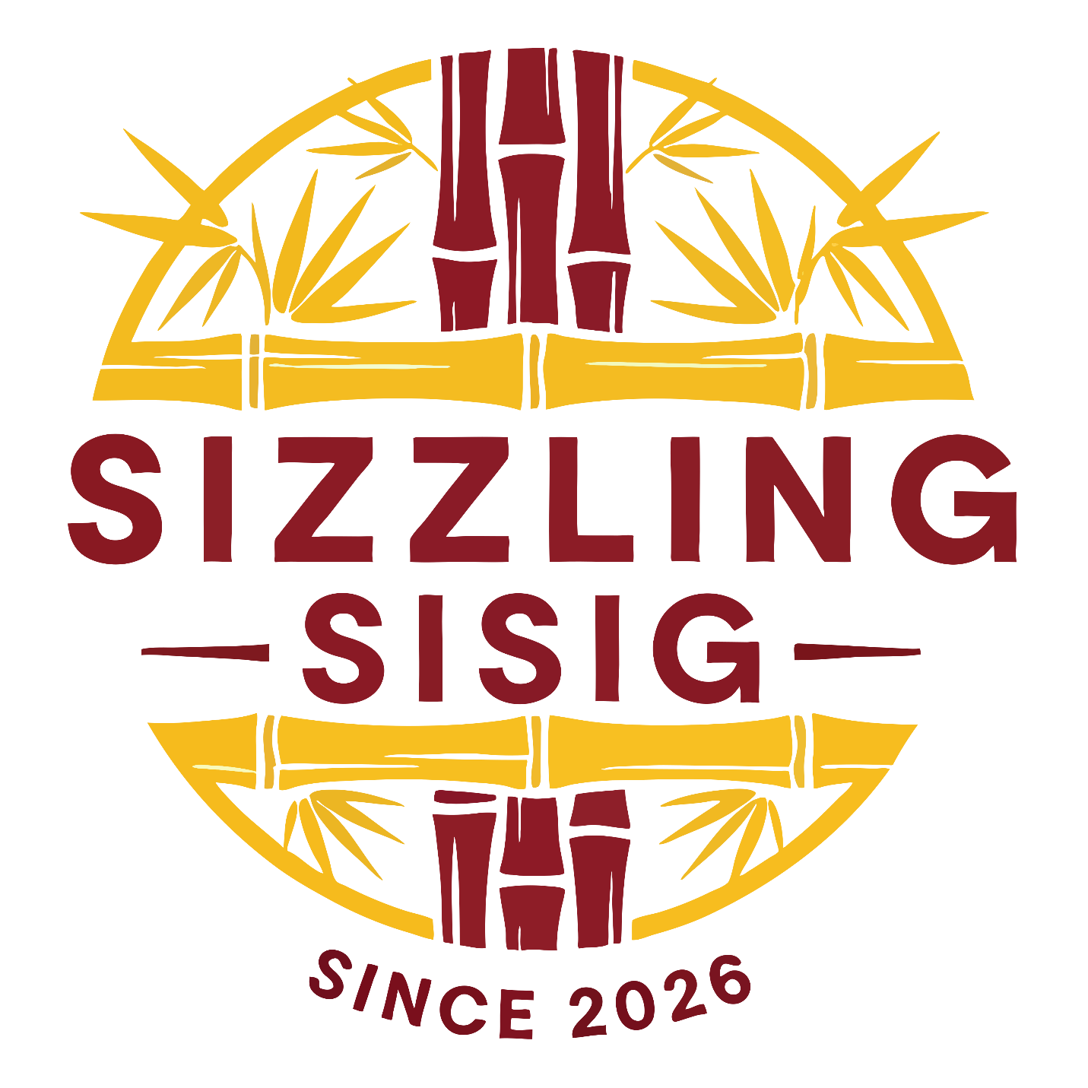

StyleGuide:
Color Pallete: 79c6d8-ffffff-000000-fce273-0c4166

Typography:
Heading Font: Eco Bamboo Fun
Paragraph Font: Courier new
Normal paragraph example

Wireframe:

